- Introduction
  - Project overviews:

IntelliSQL is an AI-powered natural language to SQL query generation web application designed to simplify database interactions for non-technical and technical users alike. The application leverages advanced large language models to convert userprovided natural language queries into accurate, context-aware SQL statements in real time. Built using Python, Streamlit, and Google’s Gemini Pro model, IntelliSQL enables users to input queries, specify database schemas, and generate SQL seamlessly through an intuitive user interface. The project addresses the growing need for efficient, intelligent, and user-friendly database querying in academic, professional, and enterprise environments.

  - Objectives:

The primary objective of IntelliSQL is to develop a user-friendly AI-powered web application that accurately converts natural language queries into contextually correct SQL statements. The project aims to simplify database interactions, ensure fast response times, enhance usability through an interactive interface, and demonstrate the practical application of large language models in real-world database querying systems.

- Project Initialization and Planning Phase
  - Define Problem Statement:
Customer Problem Statement:
In today’s data-driven environment, organizations and individuals increasingly rely on databases to store and retrieve critical information. However, interacting with relational databases typically requires strong knowledge of Structured Query Language (SQL), which poses a significant challenge for non-technical users such as students, analysts, managers, and domain experts. Even for experienced users, writing complex SQL queries can be time-consuming and error-prone. Traditional database querying tools lack intelligent assistance and contextual understanding, forcing users to manually translate their information needs into syntactically correct SQL queries. These limitations often result in incorrect queries, reduced productivity, and inefficiencies in data access and analysis. To overcome these challenges, there is a need for an intelligent, userfriendly system that enables users to interact with databases using natural language. IntelliSQL addresses this gap by leveraging advanced Large Language Models (LLMs), specifically Gemini Pro, to automatically convert natural language queries into accurate SQL statements.

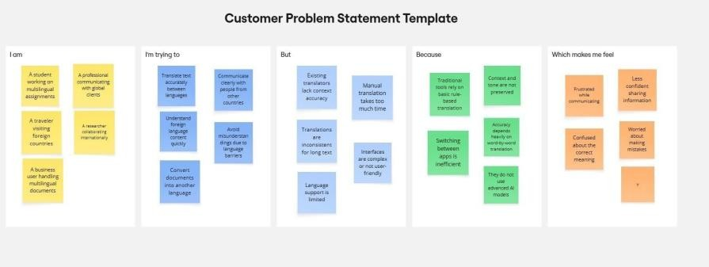
  - Project Proposal (Proposed Solution):

Category | Description
Objective | Current database querying approaches often suffer from complexity, lack of contextual understanding, limited accessibility for non-technical users, and poor usability, which negatively impact efficient and accurate data retrieval from relational databases.
Scope | Addressing these challenges will significantly enhance data accessibility, reduce queryrelated errors, and improve user confidence when interacting with relational databases. An accurate and user-friendly natural language to SQL system enables efficient academic analysis, informed business decision-making, and seamless data exploration for users across technical and non-technical backgrounds.

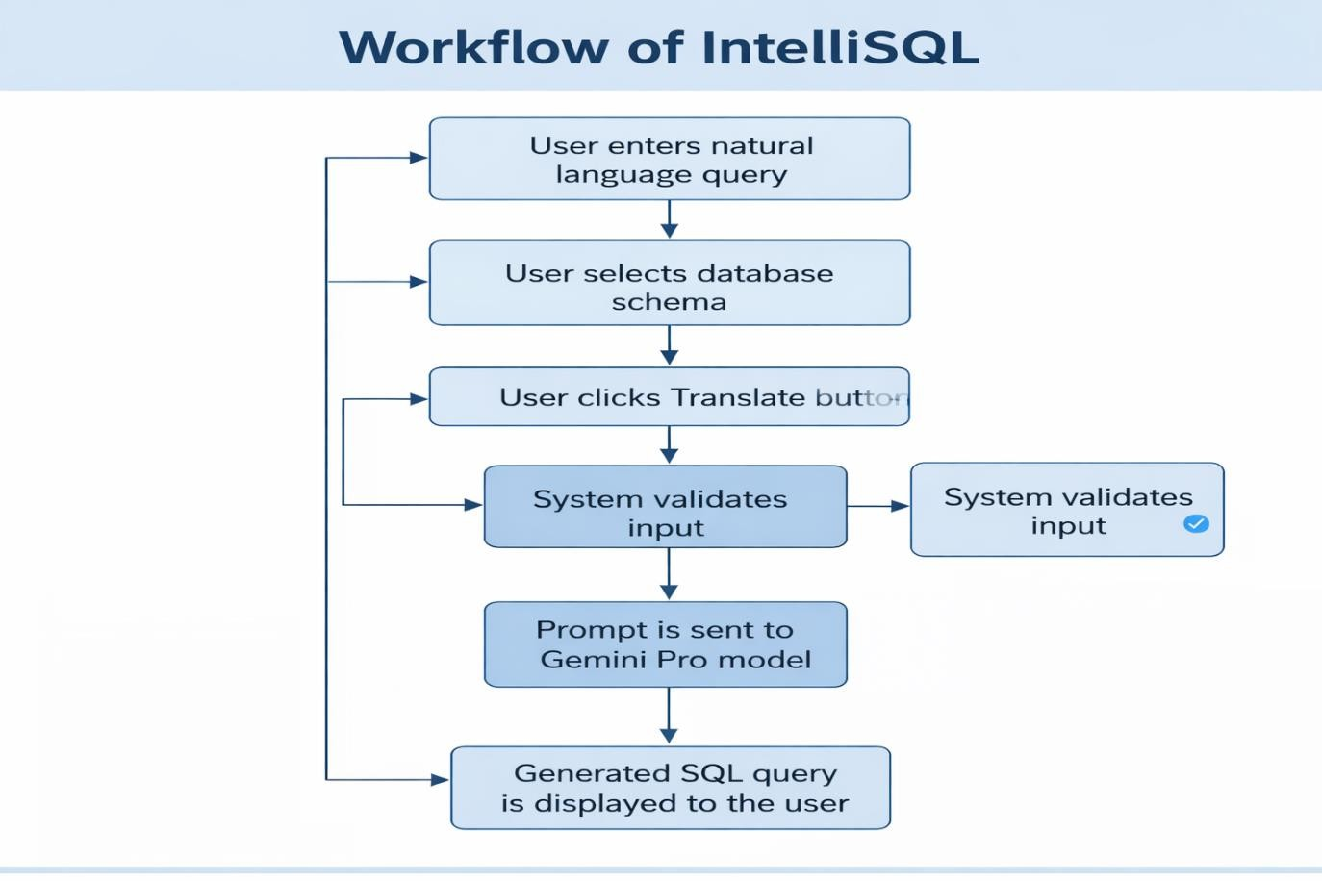

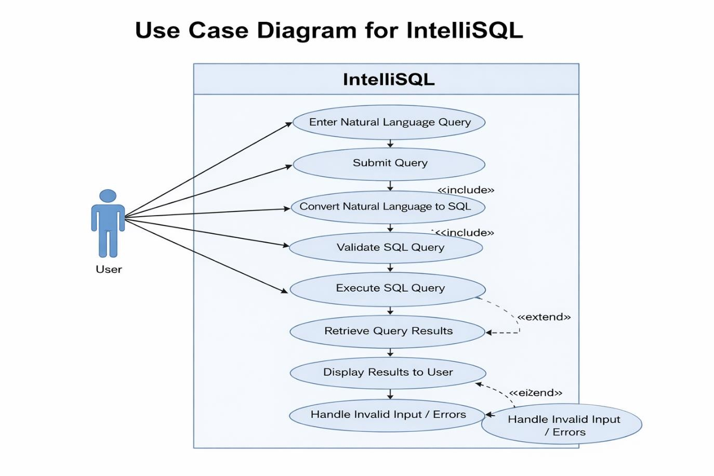

  - Initial Project Planning

Sprint | Functional  Requirement  (Epic) | User  Story No. | User Story / Task | Priority | Team Members | Sprint Start Date | Sprint End Date
Sprint-1 | Project Setup & Planning | TL-1 | Requirement analysis and project planning | High | Kuntumalla Venkata sai | 2026/01/28 | 2026/01/28
Sprint-1 | Environment Setup | TL-2 | Installing libraries & tools | Medium | Talapaneni  Venkata  Charansai | 2026/01/28 | 2026/01/28
Sprint-1 | API Configuration | TL-3 | Generating Gemini Pro API key | High | Shaik Irfan | 2026/01/28 | 2026/01/28
Sprint-2 | Model Integration | TL-4 | Initializing Gemini Pro model | High | Kuntumalla Venkata sai | 2026/01/29 | 2026/01/29
Sprint-2 | Translation Logic | TL-5 | Creating prompt template | Medium | Talapaneni  Venkata  Charansai | 2026/01/29 | 2026/01/29
Sprint-2 | Backend Function | TL-6 | Implementing translate_text() function | High | Shaik Irfan | 2026/01/29 | 2026/01/29
Sprint-3 | UI Development | TL-7 | Designing Streamlit UI | Medium | Shaik Zeba | 2026/01/30 | 2026/01/30
Sprint | Functional  Requirement  (Epic) | User  Story No. | User Story / Task | Priority | Team Members | Sprint Start Date | Sprint End Date
Sprint-3 | UI Features | TL-8 | Adding language selection & input  fields | Medium | Shaik Zeba | 2026/01/30 | 2026/01/30
Sprint-3 | Output Display | TL-9 | Displaying translated text | Low | Talapaneni  Venkata  Charansai | 2026/01/30 | 2026/01/30
Sprint-4 | Deployment | TL-10 | Local deployment using Streamlit | Medium | Kuntumalla Venkata sai | 2026/01/30 | 2026/01/30
Sprint-4 | Testing | TL-11 | Functional testing & bug fixing | High | All Members | 2026/01/30 | 2026/01/30
Sprint-4 | Documentation | TL-12 | Final project report preparation | Medium | All Members | 2026/01/30 | 2026/01/30

- Data Collection and Preprocessing Phase
  - Data Collection Plan and Raw Data Sources Identified:

Section | Description
Project  Overview | The IntelliSQL: Intelligent SQL Querying with LLMs Using Gemini Pro project aims to enable users to interact with databases using natural language queries. The system leverages a pre-trained generative AI model (Gemini Pro) to interpret user provided queries and automatically generate accurate and optimized SQL statements. Users submit queries in real time through an interactive web interface, simplifying database access for both technical and non-technical users.
Data  Collection  Plan | * Collect real-time natural language queries from users through the web-based application. * Accept contextual inputs such as database schema details, table names, and column information when required.
Raw Data  Sources  Identified | The primary raw data source consists of real-time user-provided natural language queries entered via the application interface. Additional contextual metadata, such as database schema information, is supplied dynamically during query processing.

Source Name | Description | Location / URL | Format | Size | Access  Permissions
User Input  (Streamlit UI) | Natural language queries entered by users to retrieve information from databases | AI-generated SQL queries produced based on user input and database | Text | Dynamic | Usercontrolled
Gemini Pro  Model Output | AI-generated SQL queries produced based on user input and database | Google  Generative AI  API | Text | Dynamic | API-based access

  - Data Quality Report:

Data Source | Data Quality Issue | Severity | Resolution Plan
User Input  (Text) | Empty or null text input | High | Input validation is applied, and users are prompted to enter valid text before translation.
User Input  (Text) | Unsupported or special characters | Low | Text normalization and internal model encoding handle unsupported characters gracefully.
Language  Selection | Missing source or target language selection | Moderate | Mandatory selection enforced using dropdown validation in the UI.
Real-time  Input | Extremely long text  input | Low | System processes input efficiently; warnings can be shown for unusually long text if required.

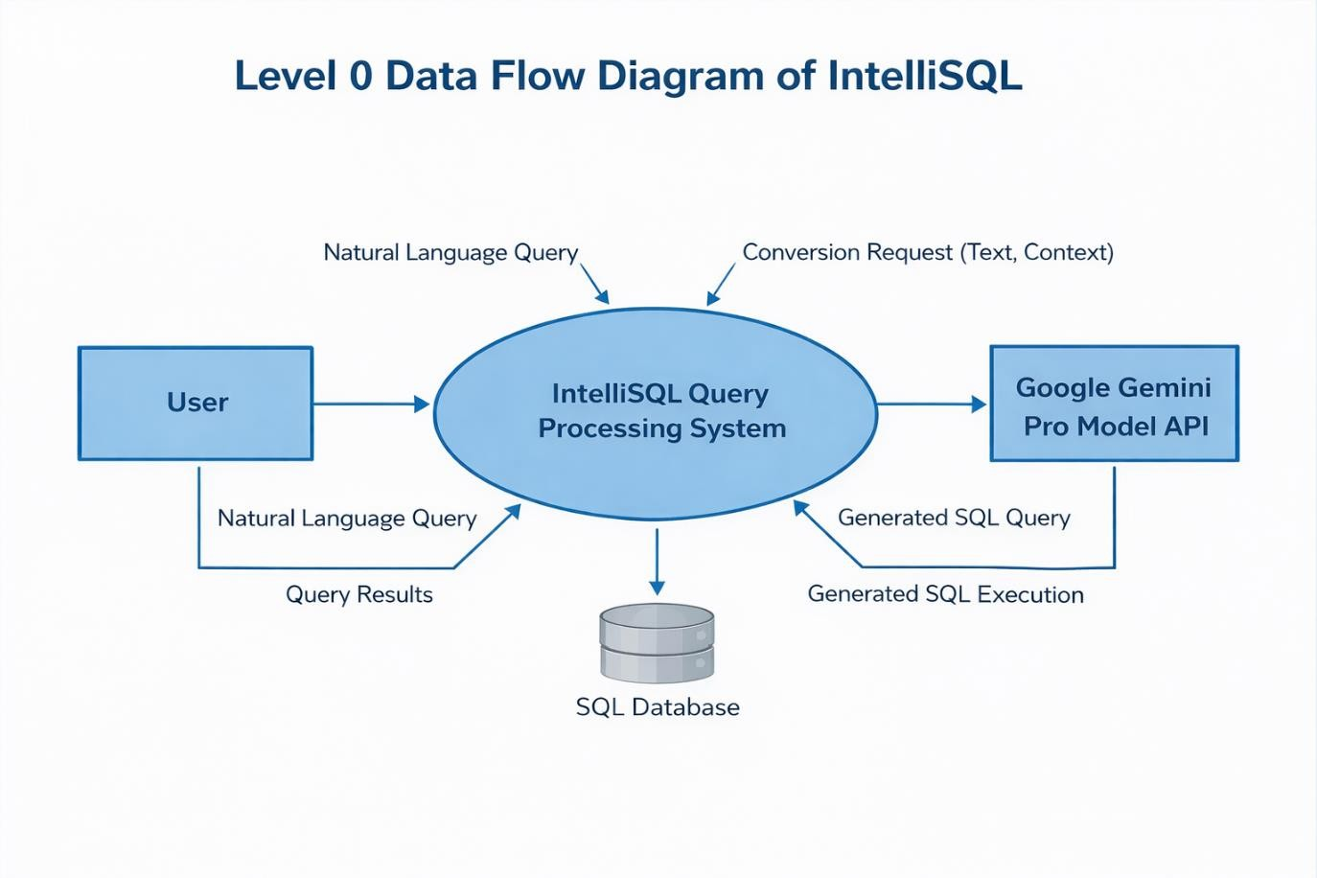

  - Data Exploration and Preprocessing:

Section | Description
Data Type | Textual data (user-provided natural language queries)
Data Source | Real-time user input collected through the Streamlit web interface
Data Format | Plain text
Data Size | Dynamic (varies based on user queries)
Nature of Data | Natural language text intended for SQL query generation

Analysis | Description
Input Text Length | 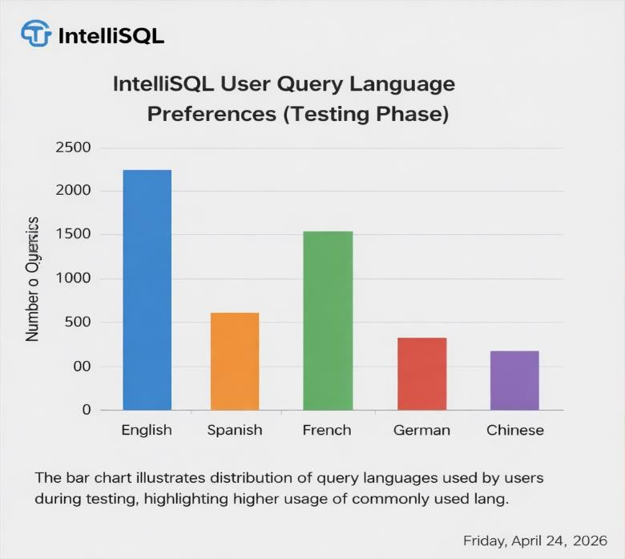  Analysis based on individual text input length
Language Type | Single-language input per request
Character Distribution | Alphabetic, numeric, and special characters

Analysis | Description
Text + Source Language +  Target  Language | Combined influence on translation accuracy and response quality
User Input Patterns | Variation in usage across different language combinations  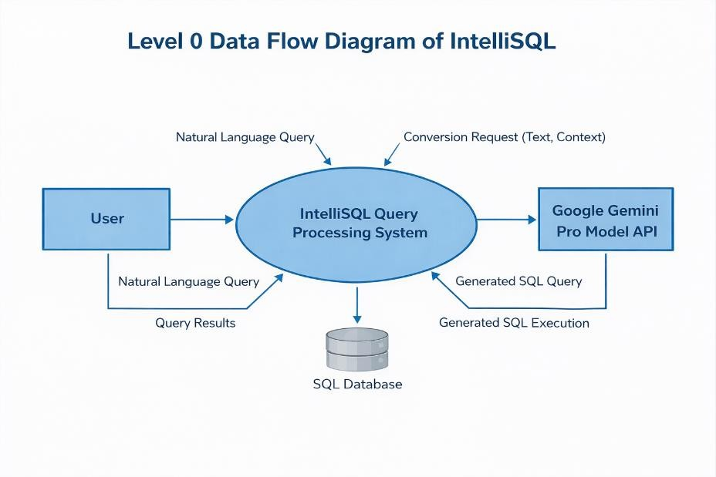

Category | Description
Outliers | Extremely long text inputs
Anomalies | Unsupported characters or empty inputs
Handling Method | Input validation and warning messages in UI  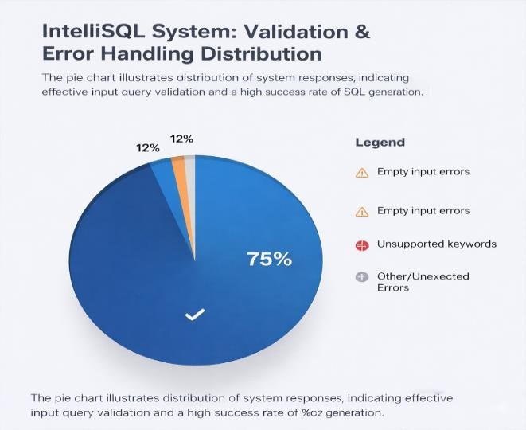

- Model Development Phase
  - Feature Selection Report:

Feature | Description | Selected  (Yes/No) | Reasoning
Input Text | Natural language query entered by the user | Yes | This is the primary input required for generating SQL queries.
Data Scheme | Tables, columns, and relationships information | Yes | Required to correctly interpret the query and generate valid SQL.
Query Intent | User’s intended operation  (SELECT, INSERT,  UPDATE, etc.) | Yes | Essential to generate the correct type of SQL statement.
Query Length | Length of the input text | No | The LLM can handle variable-length queries without explicit feature usage.
Special  Characters | Presence of symbols or  special characters | No | Handled internally by the model during encoding.
Prompt Template | Structured instruction sent to the LLM | Yes | Ensures context-aware and accurate SQL generation.
Generated  SQL  Output | SQL query generated by the model | Yes | Represents the final output and fulfills the project objective.

  - Model Selection Report:

Model | Description | Hyperparameters | Performance  Metric
Gemini Pro  (gemini1.5flash) | Pre-trained large language model capable of converting natural language queries into accurate SQL queries with strong contextual understanding. | Pre-trained (No custom hyperparameters tuned) | High SQL accuracy, strong reasoning, low latency
Rule-Based  Translator | Uses predefined rules and patterns to convert text into SQL queries. | Not applicable | Low accuracy for complex or ambiguous queries
Statistical  Machine  Translation  (SMT) | Generates SQL queries based on probabilistic language patterns. | Not applicable | Moderate accuracy
Neural  Machine  Translation  (NMT) | Uses neural networks to map natural language to SQL structures. . | Not applicable | High accuracy
Selected  Model: Gemini  Pro | Chosen due to superior context awareness, scalability, and multilingual performance compared to traditional approaches. generation compared to traditional approaches. | — | Best overall performance

  - Initial Model Training Code, Model Validation and Evaluation Report:
Evaluation Aspect | Result
Translation Quality | High
Context Awareness | High
Response Time | Low latency
Multilingual Support | Successful
Overall Performance | Satisfactory
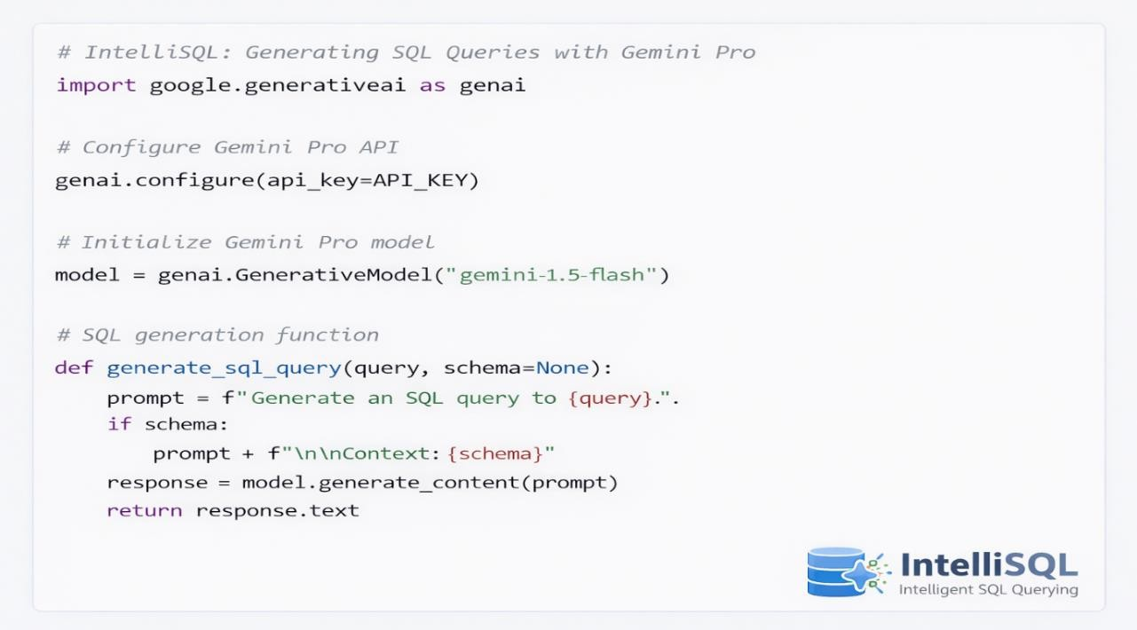

Validation Method | Description
Manual Validation | Sample natural language queries are manually converted into SQL and compared with system-generated SQL to verify correctness and intent matching.
Query Length  Testing | The system is tested using short, medium, and complex queries to evaluate consistency and performance across varying query lengths.
Query Type Testing | Multiple query types (SELECT, JOIN, WHERE, GROUP BY, etc.) are tested to ensure reliable SQL generation and correct query construction.
UI-Level Validation | Input validation is performed at the user interface level to handle empty queries, missing schema details, and invalid inputs gracefully.

- Model Optimization and Tuning Phase

  - Hyperparameter Tuning Documentation:
The Model Optimization and Tuning Phase focuses on enhancing the performance, efficiency, and reliability of the IntelliSQL system. Since the project utilizes a pre-trained Gemini Pro large language model, optimization is achieved through prompt engineering, inference configuration, and UI-level performance tuning rather than traditional hyperparameter tuning.

Model | Tuned Parameters | Optimal Values
Gemini Pro | Prompt structure | Clear instruction-based prompt specifying query intent and database schema
Gemini  Pro | Input length handling | Supports short, medium, and long natural language queries
Gemini  Pro | Temperature (Creativity control) | Default (balanced for accuracy and fluency)
Gemini  Pro | Response format | SQL query–only output
Gemini  Pro | API latency optimization | Single-call inference per request

  - Performance Metrics Comparison Report:

Optimization Aspect | Before Optimization | After Optimization
Translation Accuracy | Moderate | High
Context Preservation | Medium | Improved
Response Time | Slight delay | Reduced latency
User Experience | Basic | Enhanced and intuitive

  - Final Model Selection Justification

Final Model | Reasoning
Gemini Pro  (gemini1.5flash) | The model was selected for its strong context-aware natural language to SQL conversion, low latency, and seamless API integration. Prompt optimization and inference tuning improved accuracy and performance, making it suitable for real-time SQL query generation applications.

- Results
  - Output Screenshots
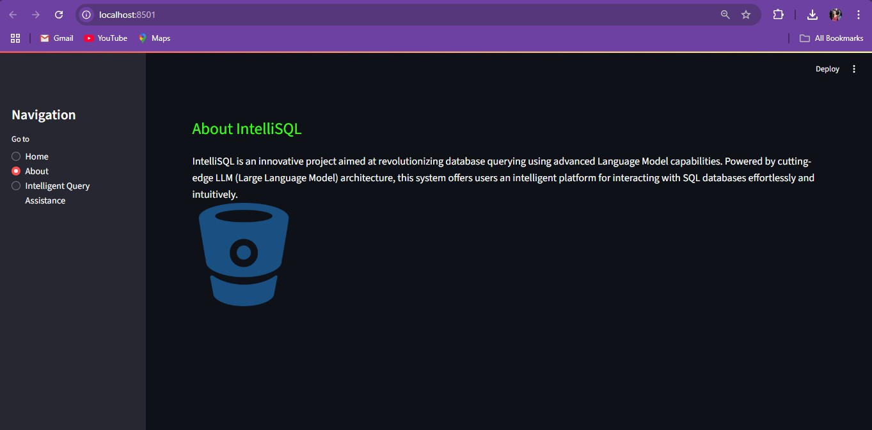

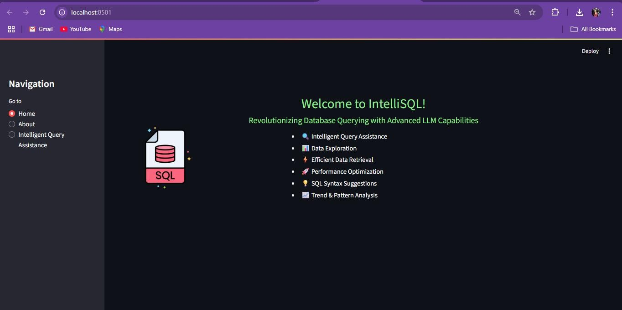

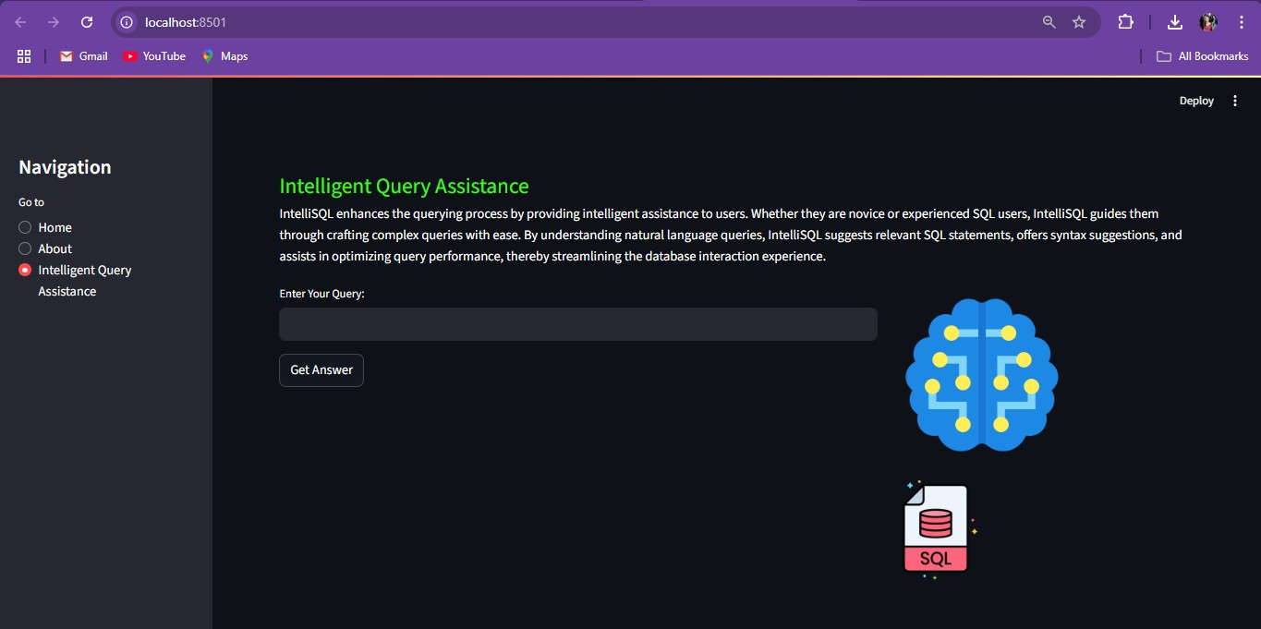

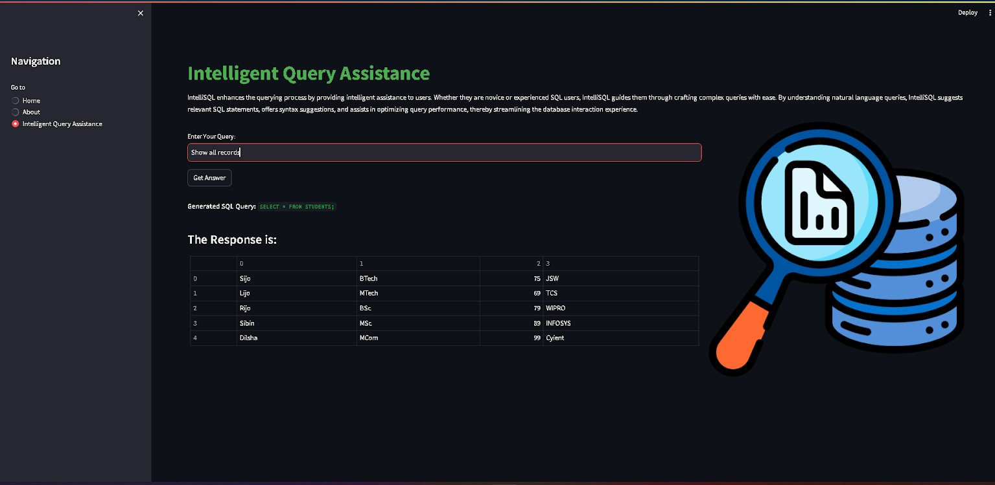

- Advantages & Disadvantages

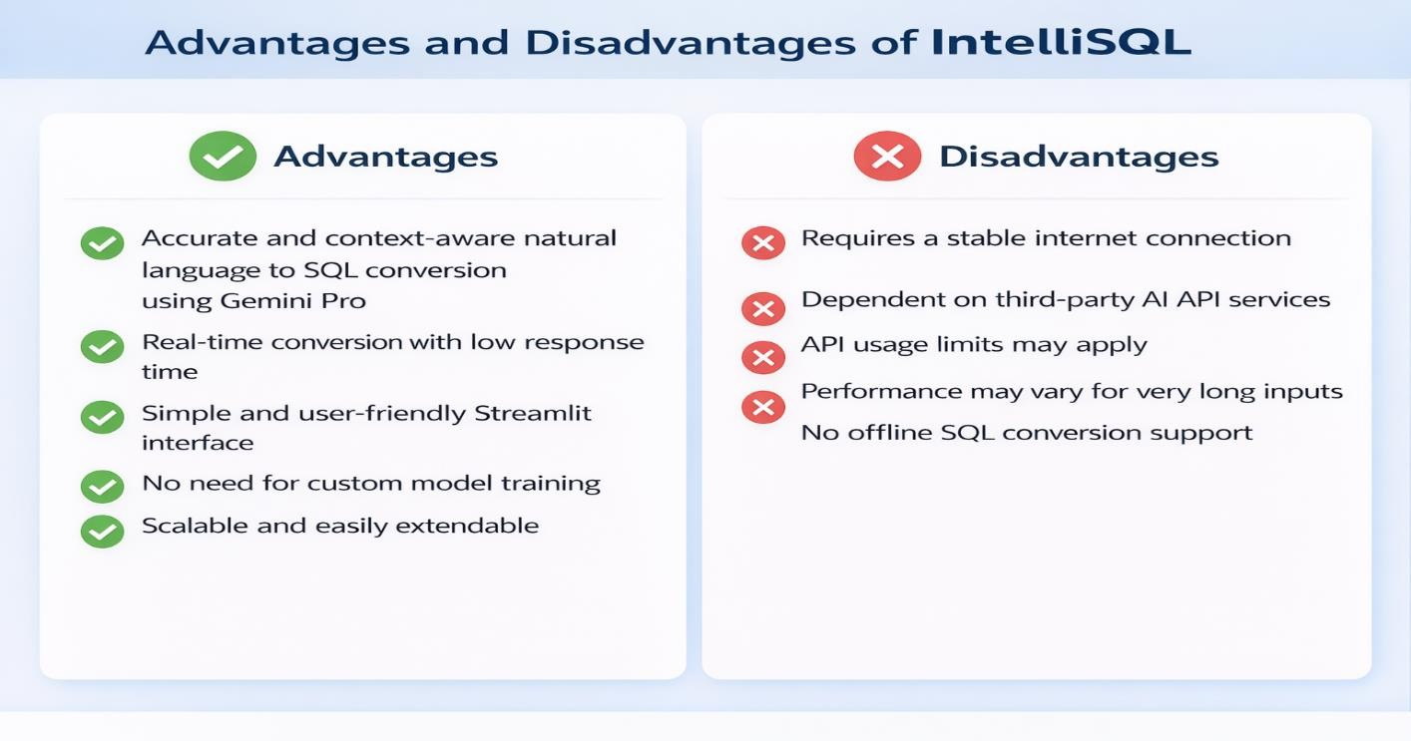

- Conclusion:

IntelliSQL successfully demonstrates the application of large language models in solving realworld database querying challenges. By integrating Gemini Pro with a Streamlit-based interface, the project enables accurate and context-aware conversion of natural language into SQL queries while maintaining simplicity and efficiency. The system effectively bridges the gap between non-technical users and structured database systems across academic and professional domains.
Future Scope

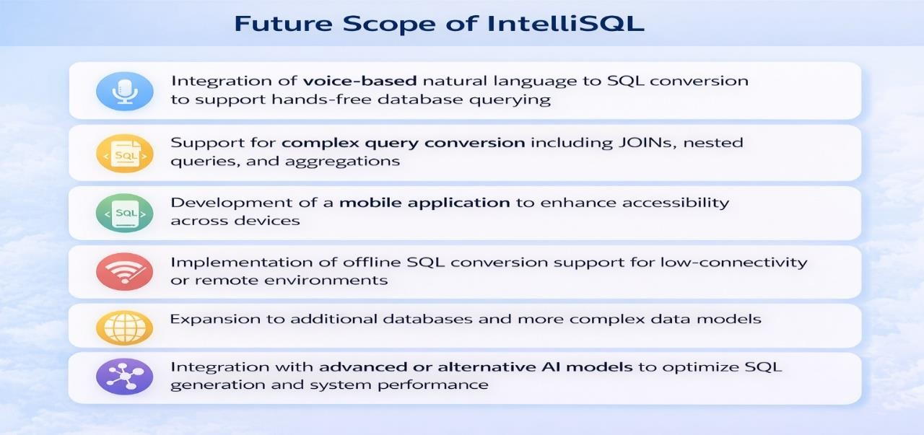

- Appendix
  - Source Code

import streamlit as st import google.generativeai as genai from dotenv import load_dotenv import os

# Load environment variables
load_dotenv()
API_KEY = os.getenv("GOOGLE_API_KEY")

# Configure Gemini API
genai.configure(api_key=API_KEY)

# Initialize Gemini Pro model
model = genai.GenerativeModel("gemini-1.5-flash")

# Function to convert natural language to SQL def generate_sql_query(user_query, database_schema):
prompt = f"""
You are an SQL expert.
Given the following database schema:
{database_schema}

Convert the following natural language query into an SQL query: {user_query}

Provide only the SQL query as output.
"""
response = model.generate_content(prompt) return response.text
# Streamlit UI st.set_page_config(page_title="IntelliSQL", page_icon="🗄️") st.title("🗄️ IntelliSQL – Natural Language to SQL Generator")

database_schema = st.text_area("Enter database schema") user_query = st.text_area("Enter your natural language query")

if st.button("Generate SQL"): if not database_schema or not user_query:
st.warning("Please provide both schema and query") else:
sql_query = generate_sql_query(user_query, database_schema) st.subheader("Generated SQL Query") st.code(sql_query, language="sql")

Project: IntelliSQL: Intelligent SQL Querying with LLMs Using Gemini Pro

9.2. GitHub & Project Demo Link

GitHub : https://github.com/saisreeja6905/IntelliSQL-Gemini.git

Demo Link : https://youtu.be/0O-6uz9e9Eo

